**RV College of Engineering**​**®**​**, Bengaluru – 59**

**Department of Computer Science and**

**Engineering Database Design Laboratory**

**(18CS53)**

# Requirement Specification

|  |  |  |
| --- | --- | --- |
| **TITLE** | **eSports Community** | |
| **TEAM** | **USN**​: 1RV18CS102 **USN**​: 1RV18CS096 | **NAME**​: Neil Nagaraj Havanur  **NAME**​: Nachiket G Kallapur |

## 1 Hardware Specification

### Minimum

* **Processor:** Dual core 32-bit 1 GHz processor​
* **Primary memory:** 2 GB RAM
* **Secondary memory:** 4​ GB Storage of HDD or SSD

### Recommended

* **Processor:** Quad core 64-bit 2 GHz processor​
* **Primary memory:** 4​ GB RAM
* **Secondary memory:** 10​GB Storage of HDD or SSD

## 2 Software Specification

To implement the clinic management system for running the web application, we need a Linux operating system of any flavour that is compatible with the following software:

* ReactJS
* MySQL
* NodeJS and npm/yarn
* Firebase

## 3 Functional Requirements

The web app is required to be able to perform the following functions:

Registration

* Players, Companies and Clans will have a separate page for registration.
* Players will have to register by providing their username, age, sex, Youtube channel if any and their location.
* Companies will have to register by providing their Name, location and a short bio.
* Clans will have to register by providing their username, clan size(ranges from 20-500) and whether they play casually or competitively.
* Game will be added on the day of the release by the admin.
* A player can request to join a clan of his/her interest.

Statistics

* Player statistics is determined by the quality of the players’ gameplay like survival time, headshot percentage, number of kills etc.
* Activity of a player is the amount of time he spends on the particular game. It is determined by factors like his statistics as well as the amount of participation in his/her clan.
* Player level is determined by the players’ activity in a particular clan.

UI and UX

* A good User Interface as well as User Experience is provided with all the necessary functionalities required for a good gaming experience.

Events

* The web application provides an option to host events.
* Events generally have a prize pool.
* Players can participate in the events through clans or just by themselves.
* Companies recruit players based on their performance during the event.

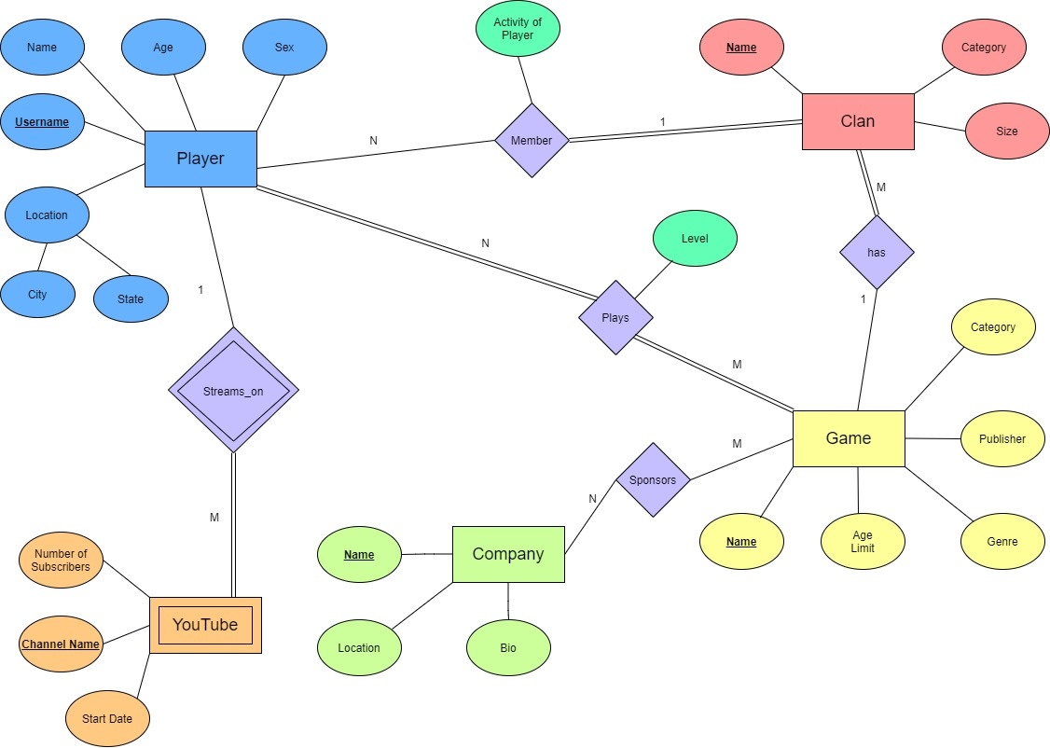**Entity Relationship Diagram**

**ER to relational model mapping**

**Player**

|  |  |  |  |  |  |
| --- | --- | --- | --- | --- | --- |
| P_name | P_age | P_sex | **P_username** | P_city | P_state |

**YouTube**

|  |  |  |  |
| --- | --- | --- | --- |
| Y_subscribers | **Y_channelName** | Y_startDate | **P_username** |

**Clan**

|  |  |  |  |
| --- | --- | --- | --- |
| **C_name** | C_category | C_size | G_name |

**Game**

|  |  |  |  |  |
| --- | --- | --- | --- | --- |
| **G_name** | G_category | G_ageLimit | G_genre | G_publisher |

**Company**

|  |  |  |
| --- | --- | --- |
| **Comp_name** | Comp_location | Comp_Bio |

**Player_plays_Game**

|  |  |  |
| --- | --- | --- |
| **P_username** | **G_name** | level |

**Company_sponsors_Game**

|  |  |
| --- | --- |
| **Comp_name** | **G_name** |

**Player_isMemberOf_Clan**

|  |  |  |
| --- | --- | --- |
| **P_username** | **C_name** | activity |